

100 DAYS RTL PART-1

Day 71: QUEUE

Day 72: CLOCKING BLOCKS

Day 73: APB SLAVE

Day 74: ENUMeRATION

Day 75: STRUCTURES

Day 76: MAILBOX

Day 77: SENDING TRANSACTION DATA WITH MB

Day 78: PARAMETERIZED MAILBOX

Day 79: SEMAPHORE

Day 80: ASSOCIATIVE ARRAY

Day 71: Queue
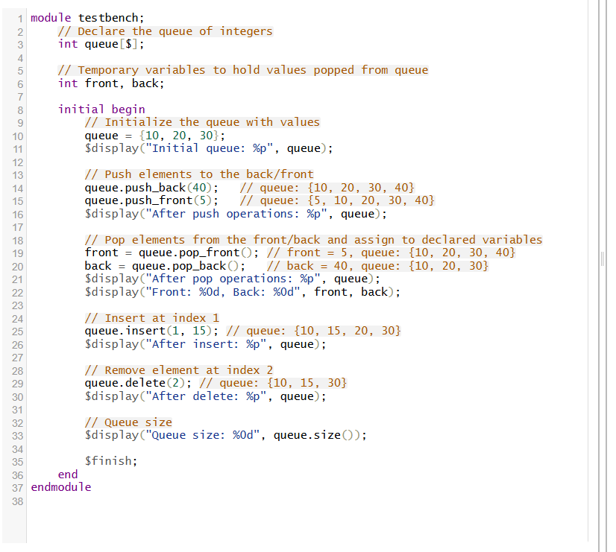
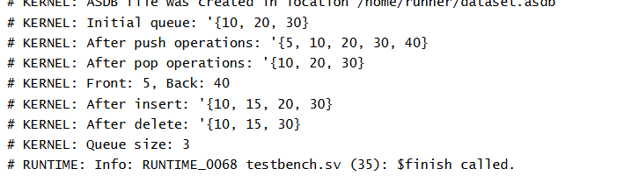

Explanation of the SystemVerilog Queue Example
1. What is a SystemVerilog Queue?
A queue in SystemVerilog is a dynamic, ordered collection of elements, similar to an array, but with flexible sizing. Queues are commonly used for modeling FIFO (First In, First Out) structures, temporary storage, or any situation where elements need to be added and removed from both ends.
Key Features:
- Dynamic size: Automatically expands and contracts as elements are added or removed.
- Random access: Elements can be accessed by index.
- Powerful methods: Methods such as push_front, push_back, pop_front, pop_back, insert, delete, and size enable powerful manipulation.
Operations Demonstrated:
- Initialization:
queue = {10, 20, 30};
Initializes queue to three integer values.
- Pushing (Adding) Elements:
  - queue.push_back(40); adds 40 at the end (right).
  - queue.push_front(5); adds 5 at the start (left).
- Popping (Removing) Elements:
  - front = queue.pop_front(); removes the first (leftmost) element and stores it in front.
  - back = queue.pop_back(); removes the last (rightmost) element and stores it in back.
- Inserting and Deleting:
  - queue.insert(1, 15); inserts 15 at index 1 (second position).
  - queue.delete(2); removes the element at index 2.
Practical Use Cases
- Testbenches use queues to drive sequences of data.
- Bus modeling (e.g., AXI, PCIe FIFOs) often employ queues for in-flight transactions.
- Scoreboarding in verification environments tracks packet/data order.
Summary Table: Key Queue Methods Used
Method | Action
push_back(val) | Adds val to the end of the queue
push_front(val) | Adds val to the front of the queue
pop_front() | Removes & returns the first item
pop_back() | Removes & returns the last item
insert(idx, val) | Inserts val at index idx
delete(idx) | Removes the element at index idx
size() | Returns the current length

Day 72: Clocking Blocks
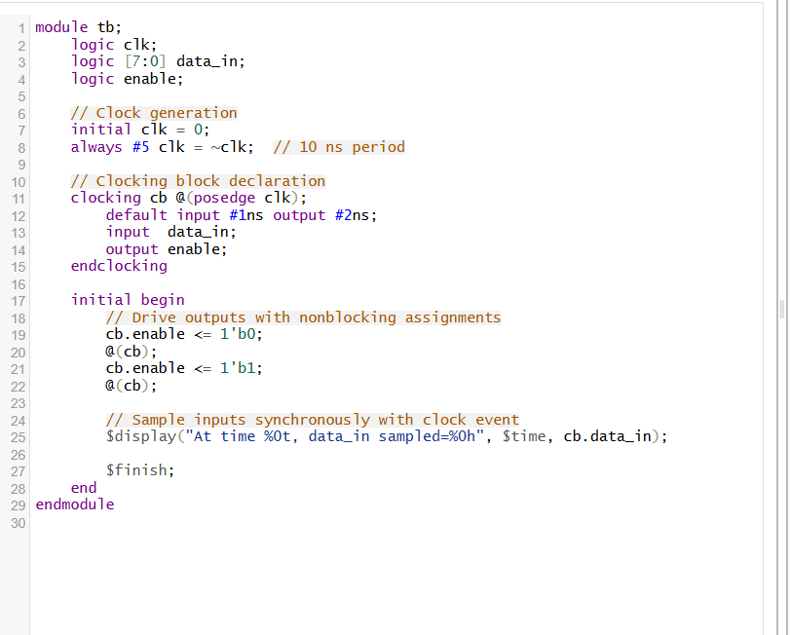
# KERNEL: Time: 15 ns, Iteration: 0, Instance: /tb,
1. What is a Clocking Block in SystemVerilog?
A clocking block is a construct introduced in SystemVerilog to help synchronize handshake and signal sampling with a specific clock event in testbenches and verification environments. It defines a timing domain or interface where signals are sampled and driven relative to a clock edge.
2. Why Use Clocking Blocks?
- Timing clarity and synchronization: Groups related signals and associates them to a clock's edge.
- Improved readability: Signals are accessed through the clocking block, clearly indicating their synchronization.
- Control of timing skews: You can specify input and output skews (delays before and after clock edge with which inputs are sampled and outputs driven).
- Simplifies timing bugs: For example, it ensures outputs are driven only after the clock edge in a non-blocking manner,
3. How Signals Are Accessed and Assigned
- Inputs inside the clocking block (like data_in) are sampled by reading Sampling occurs respecting input skew (1 ns before clock edge).
- Outputs (like enable) must be driven using nonblocking assignments (<=) to avoid race conditions and guarantee proper sequencing after the clock edge (respecting output skew).
4. Summary
Concept | Explanation
Clocking block | Groups signals synchronized to a clock edge
Clocking event | The exact clock edge that defines when signals change or sampled
Input skew | Time before clock edge inputs are sampled
Output skew | Time after clock edge outputs are driven
Nonblocking <= | Required for driving clocking block outputs
@(cb) event | Waits for the clocking event (e.g., posedge clk)
Day 73: APB SLAVE
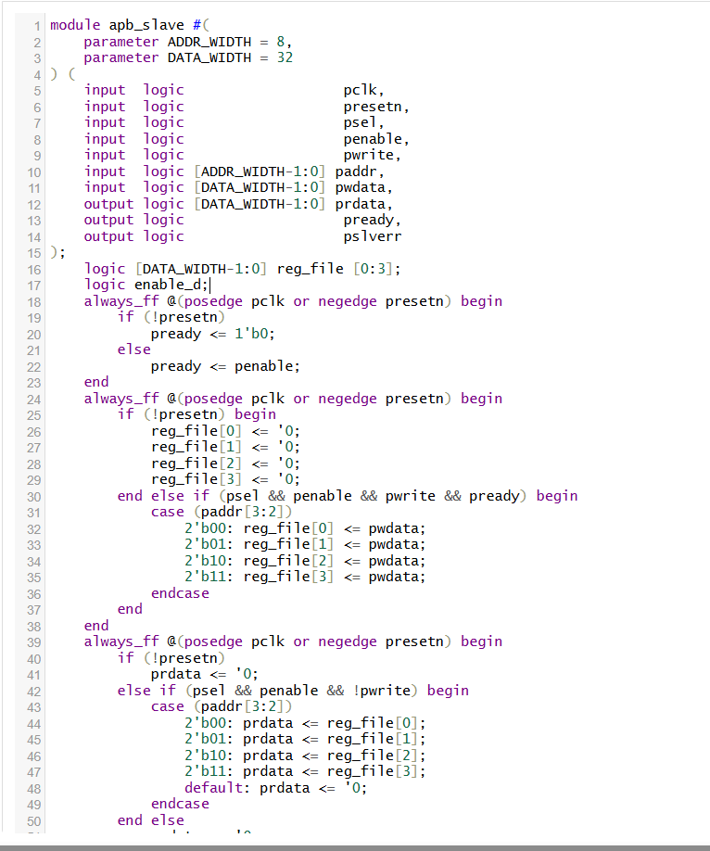

Theory Explanation of the APB Slave Module
1. What is the APB Protocol?
The Advanced Peripheral Bus (APB) is a simple, low-power bus protocol primarily used for connecting peripherals in SoCs. It is a part of the ARM AMBA protocols hierarchy and is designed for low complexity and low power with a non-pipelined interface.
2. APB Slave Interface Signals Overview
- pclk: APB clock signal.
- presetn: Active-low asynchronous reset.
- psel: APB select signal; asserted when a transfer is intended for the slave.
- penable: Enable signal; distinguishes between setup phase and access phase.
- pwrite: Write/read indicator; 1 = write, 0 = read.
- paddr: Address bus for selecting registers/memory inside the slave.
- pwdata: Write data bus containing data to be written.
- prdata: Read data bus driven by the slave during read transfers.
- pready: Indicates slave is ready to complete the transfer.
- pslverr: Protocol error indicator from the slave (optional).
3. APB Transfer Phases
The APB transfer occurs in two phases:
- Setup Phase: psel = 1, penable = 0.
- Access Phase: psel = 1, penable = 1.
Data is transferred (read or write) during the access phase.
4. Module Internal Structure Overview
a) Register File
- Contains 4 registers (reg_file[0..3]) each DATA_WIDTH bits.
- Address bits [3:2] are used to decode which register is accessed.
b) Pready Signal Generation
- pready is asserted during the access phase (penable high), indicating the slave is ready to complete the transfer.
- This model assumes zero wait states for simplicity, so pready mirrors penable.
c) Write Operation
- Occurs on the rising edge of pclk during the access phase (when psel && penable && pwrite && pready is true).
- Data from pwdata is written into the selected register, based on paddr[3:2].
d) Read Operation
- Also synchronized with pclk.
- During the read phase (psel && penable && !pwrite), the slave drives the addressed register data onto prdata.
- If no read is occurring, prdata outputs zero.
e) Reset (presetn)
- Asynchronous active-low reset.
- Upon reset, all registers and outputs are initialized to zero.
f) Error Signal (pslverr)
- This code does not implement errors, so pslverr is always zero.

Day 74: Enumeration
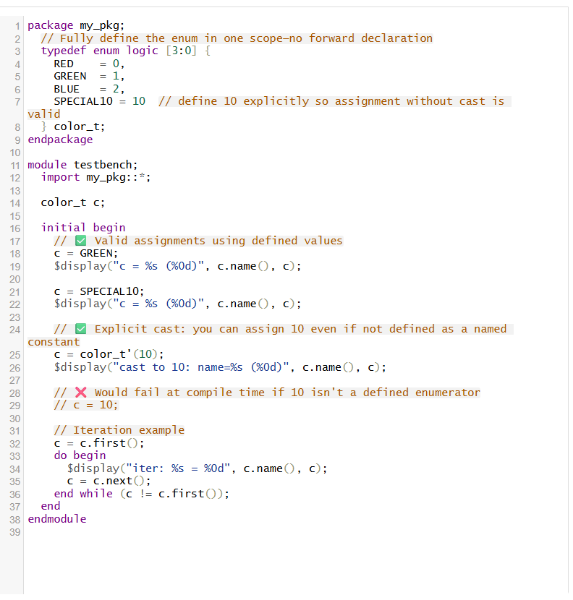
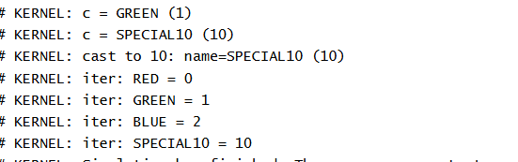

🧠 1. What Is an Enumeration?
- An enum defines a new user-defined type made up of named constants (enumerators). It maps names to integer values for readability and strong typing
- Typical usage: typedef enum {IDLE, RUNNING, DONE} fsm_t;
Here, IDLE = 0, RUNNING = 1, DONE = 2 by default
🔢 2. Value Assignment: Implicit & Explicit
- Default behavior: the first enumerator gets value 0; subsequent ones auto-increment.
- You can explicitly assign values at any position. Unspecified enumerators continue incrementally unless overridden
Example chain:

🛡️ 3. Strong Typing Rules
- Enumerated types are strongly typed. You cannot assign an arbitrary integer unless:
  - That integer matches one of the defined enumerator values, or
  - You use an explicit cast:

⚙️ 4. Built-in Enumeration Methods
SystemVerilog defines built-in methods for introspection and traversal:
- first(): returns the first enumerator
- last(): returns the last enumerator
- next(N), prev(N): step ahead or back N values
- num(): total number of enumerators
- name(): string name of the current enumerator

🧭 5. Why Use Enums?
- Readability: Named constants replace magic numbers; easily understandable code
- Maintainability: Changing mapped values in one place updates all use cases.
- Type Safety: Helps catch invalid assignments early in simulation or compile time.
- Error Detection: Forward declarations or unresolved typedefs cause errors, helping catch missing definitions They are particularly common in:
- Finite State Machines (FSMs)
- Protocol encoding / opcodes
- Configuration parameters and modes
- Replicating discrete options for test benches

Day 75: Structures

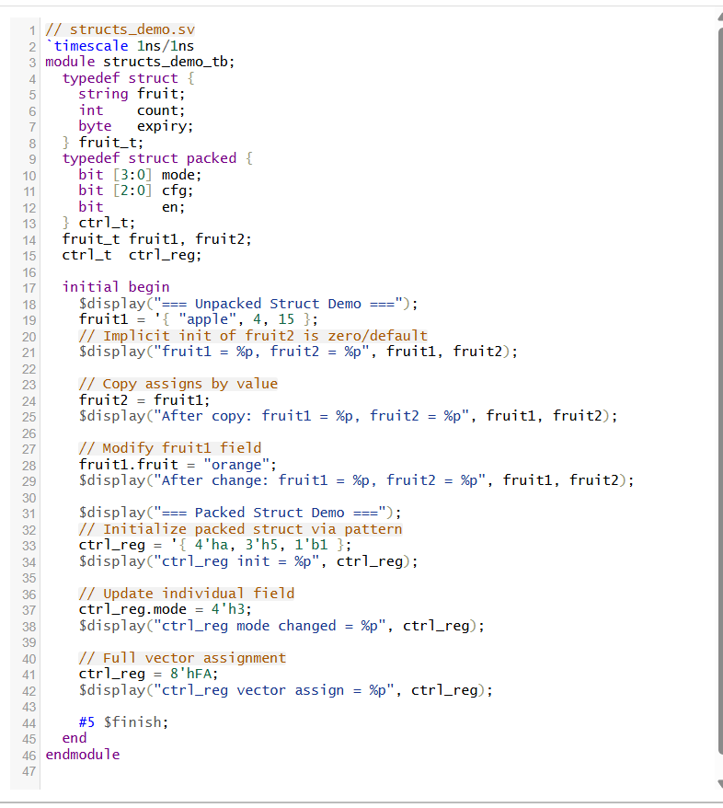
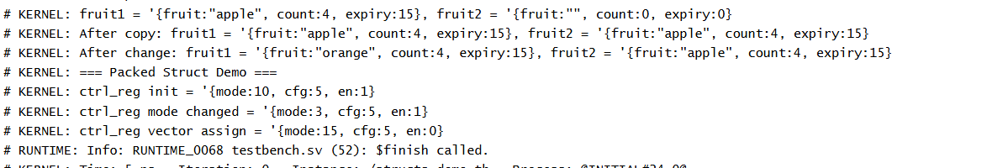
📘 1. What Is a Struct?
A struct in SystemVerilog is a composite (or aggregate) data type that groups multiple variables of possibly different types under one name, similar to C-style structs
Unlike arrays, which hold homogeneous data types, structs are ideal for logically bundling related but heterogeneous fields—such as signals of a bus protocol, transaction packets, or record entries
2. Packed vs. Unpacked Structs
- Unpacked Struct (default):
Declares fields independently in memory; not synthesizable as a contiguous vector. Flexible and suitable for testbench data or complex types like strings and enums
- Packed Struct:
Defined with struct packed, it tightly maps all fields into a contiguous bit vector. Synthesizable and supports bit-level operations and vector assignment. The first field represents the most significant bits Packed structs allow slicing and arithmetic across the entire vector and are often used for control/status registers or protocol fields
3. Initialization, Assignment & Access
- Dot notation: Access fields like mystruct.field1.
- Aggregate assignment: Use '{…} to initialize fields in declared order.
- Copying struct instances: Value-based copy; one instance's change doesn’t affect the other
4. Important Behaviors & Constraints
- Packed struct bit ordering: The first member becomes the most significant bits, with subsequent members following in decreasing significance. This structure matches flat vector layouts for easy bit slicing
- Field-level safety: Structs prevent misuse of arbitrary bit-vectors; assignment must respect matching layouts or types

Day 76: Mailbox
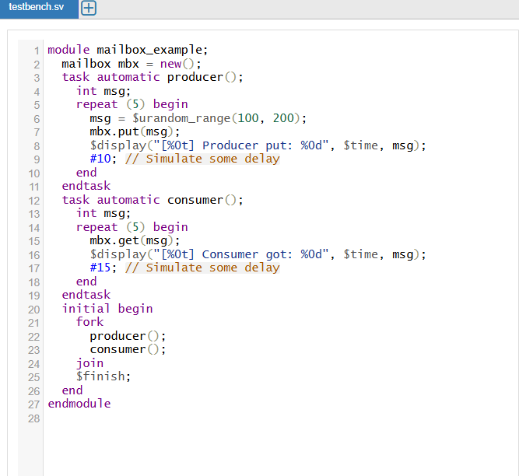
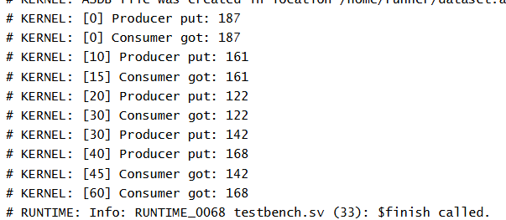

A mailbox in SystemVerilog is a thread-safe communication mechanism used for data exchange between parallel processes or components, especially in testbenches for verification. It acts like a queue (FIFO - first-in, first-out), allowing one process (the producer) to put data into the mailbox and another process (the consumer) to retrieve data from it.
Core Concepts
- Synchronization: Mailboxes ensure synchronized data transfer. This means when a process tries to get data from an empty mailbox, it waits (blocks) until data is available. Similarly, if a process tries to put data into a full (bounded) mailbox, it waits until space is available.
- Unbounded vs. Bounded:
  - Unbounded mailbox: No limit to how many items it can hold. mailbox mbx = new();
  - Bounded mailbox: Has a fixed storage capacity. If full, any further put() calls will block. mailbox mbx = new(5); means only 5 items can be stored at a time.

Main Methods
- put(item): Place an item in the mailbox. Blocks if the mailbox is full (for bounded mailboxes).
- get(var): Retrieves and removes the next item. Blocks if empty.
- try_put(item) / try_get(var): Non-blocking versions of put/get, returning success/failure status instead of waiting.
- peek(var) / try_peek(var): Look at the next item without removing it.
- num(): Returns the number of messages currently in the mailbox.
Summary
A mailbox provides a simple yet robust way to synchronize and safely exchange data between independent processes running in parallel, making it essential for reliable testbench design

Day 77: Sending Transaction Data With MB
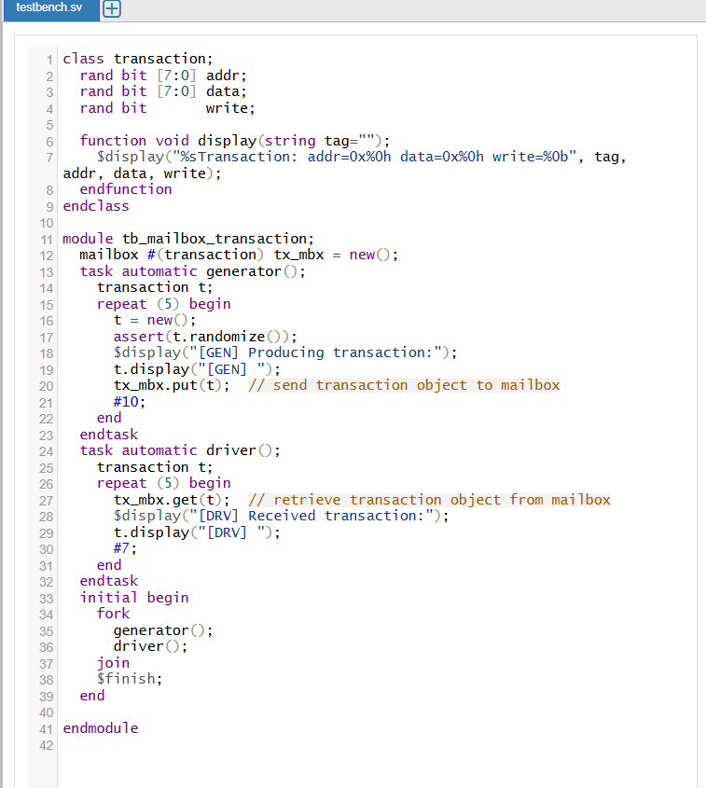
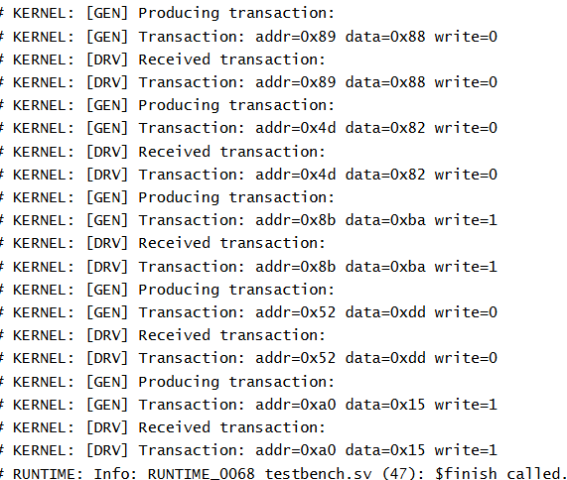

A mailbox in SystemVerilog is a built-in communication mechanism designed for safe, synchronized data exchange between multiple parallel processes or components, often used in testbenches. It acts like a first-in, first-out (FIFO) queue where one process (the producer) places data items into the mailbox using put() and another process (the consumer) retrieves data using get().
Key Theory Points of Mailbox:
- Thread-Safe Synchronization: Mailbox operations like put() and get() are synchronized and blocking. If the mailbox is empty, a get() waits until data arrives. If the mailbox is bounded and full, a put() waits until there is space. This ensures processes are automatically synchronized without explicit handshaking.
Importance and Typical Usage:
- Synchronization and Communication: Mailboxes enable safe communication between concurrently running tasks or processes without race conditions.
- Common in Verification: Used heavily in testbenches to connect generators, drivers, and monitors, facilitating stimulus transfer and result collection.
- Flexible and Easy to Use: Mailboxes simplify data passing without complex signaling, making testbench coding more modular and readable.
Summary
SystemVerilog mailboxes provide a robust and synchronized communication channel for passing messages or transaction objects between parallel processes. They ensure thread safety, optional capacity limits, and can be tailored to specific data types, making them essential for effective verification environments.

Day 78: Parameterized Mailbox
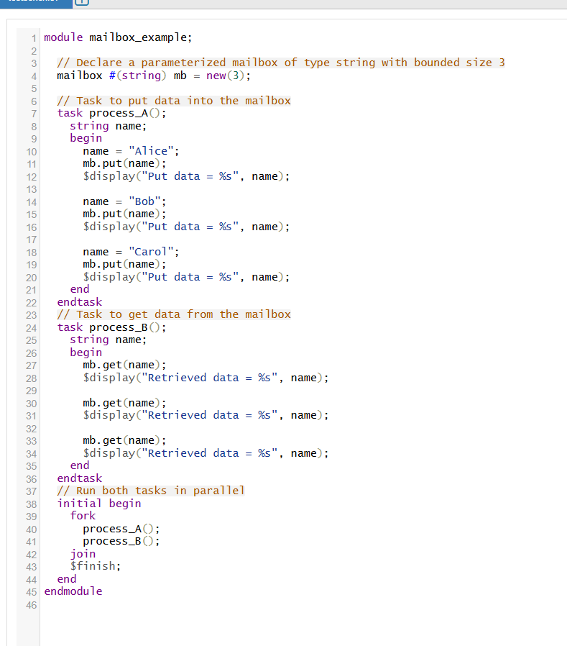
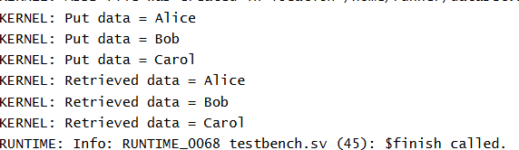
- Mailbox Basics: A mailbox is a built-in SystemVerilog mechanism used to pass messages or data items safely between concurrently running processes or threads, typically in testbenches. It acts internally like a FIFO queue where one process puts data and another gets it.
- Parameterized Mailbox: Using mailbox #(type) declares a mailbox that accepts only data of a specific type, enhancing type safety and clarity. For example, mailbox #(string) only holds strings, and mailbox #(transaction) only holds transaction objects.
- Bounded vs. Unbounded: The mailbox can be bounded (with fixed size, e.g., new(3)) or unbounded (no size limit, new()). In bounded mailboxes, a put() blocks if the mailbox is full; in unbounded, put() never blocks due to space.
- Synchronization and Blocking Behavior:
  - The put() method blocks if the mailbox is full (only for bounded mailboxes) until space is freed.
  - The get() method blocks if the mailbox is empty until data arrives.
This blocking ensures automatic synchronization between producer and consumer without additional signaling.
- Parallel Execution with fork-join: The producer (putting data) and consumer (getting data) run concurrently using fork...join, allowing seamless data exchange in simulation.
Day 79: Semaphore
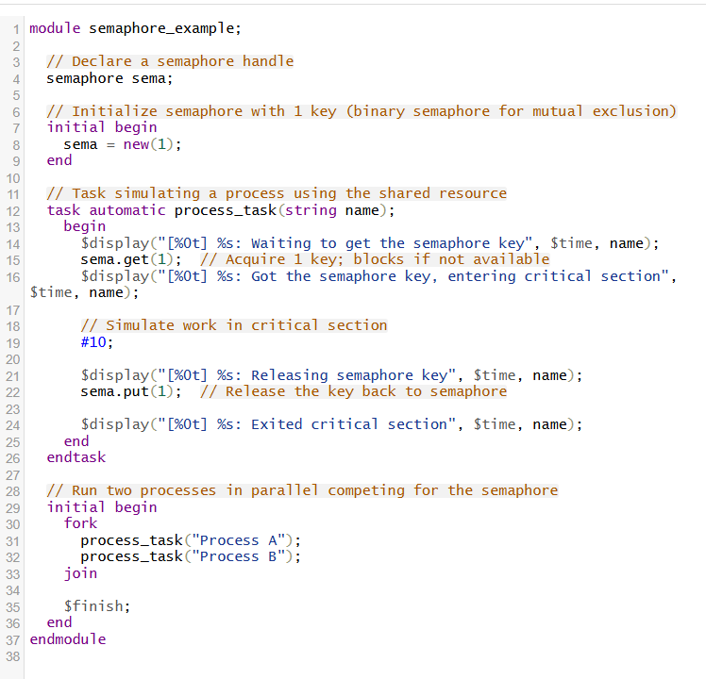
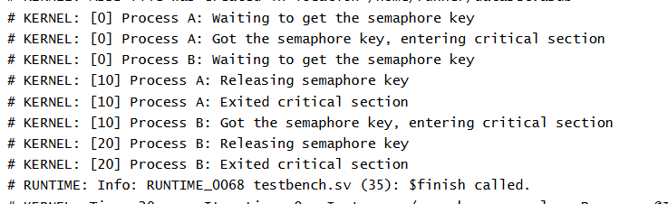
A semaphore in SystemVerilog is a synchronization primitive used to control access to shared resources among multiple parallel processes or threads. It helps prevent race conditions and ensures mutual exclusion (mutex) or coordinated access by maintaining a fixed number of "keys" or permits.
Key Concepts:
- Semaphore Keys (Count):
  - A semaphore is initialized with a certain number of keys (or units). For example, new(1) means the semaphore has one key, allowing only one process to access the critical section at a time (binary semaphore).
  - If initialized with a number greater than 1, several processes can concurrently hold keys, useful for controlling access to limited identical resources.
- Acquire and Release Operations (get and put):
  - get(num_keys): Attempts to acquire the specified number of keys (units). If enough keys are available, it decrements the semaphore count by that number and allows the process to continue.
  - If keys are not available, the process blocks (waits) until keys are released by other processes. This ensures synchronization and mutual exclusion.
  - put(num_keys): Releases the specified number of keys back to the semaphore, increasing the count and potentially unblocking waiting processes.
- Blocking Behavior:
The get() method blocks when the desired keys are unavailable, preventing concurrent access beyond the permitted limit. This effectively serializes access when the semaphore count is 1 (binary semaphore).
- Mutual Exclusion Example:
When initialized with one key (new(1)), the semaphore acts as a mutex ensuring:
  - Only one process enters the critical section at a time.
  - Other processes trying to acquire the semaphore must wait (block).
  - When the process finishes, it releases the key, enabling another waiting process to proceed.

Day 80: Associative Array
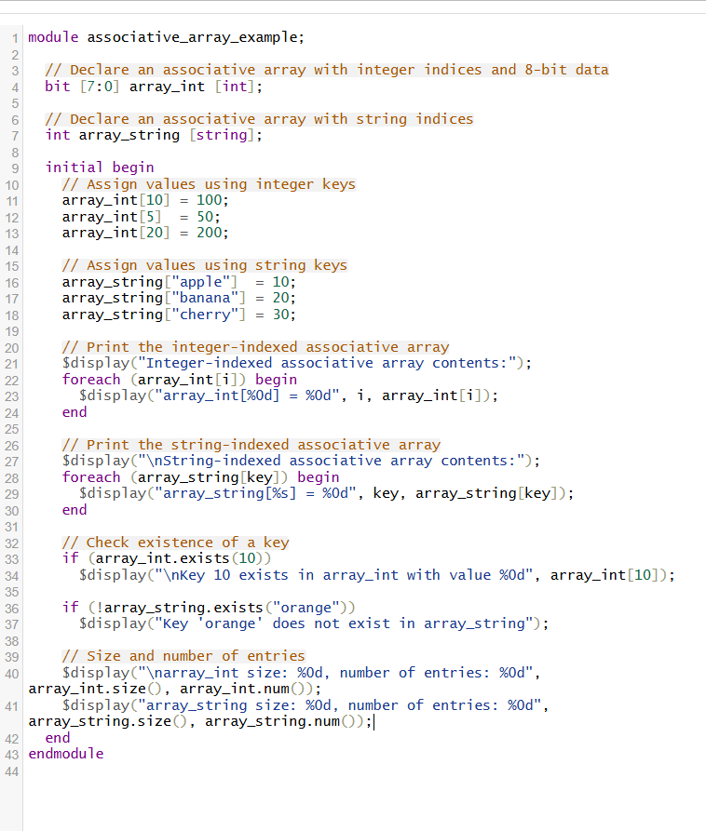
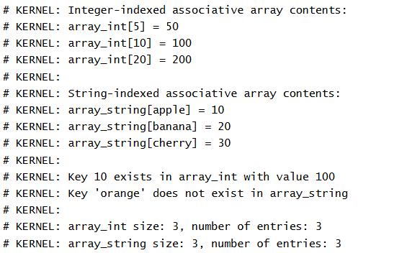

An associative array in SystemVerilog is a dynamic, sparse, and dictionary-like data structure that allows indexing with arbitrary data types such as int, string, or other scalar types. Unlike fixed-size arrays, associative arrays do not require the size or indices to be known at compile time.
Key Characteristics
- Dynamic and Sparse
  - The number of elements can grow or shrink at runtime.
  - Only the assigned indices consume memory; unassigned indices do not consume resources.
- Flexible Indexing
  - Indices can be integers, strings, or any scalar type, unlike packed or fixed arrays which are always indexed by integers.
  - This makes associative arrays ideal for cases where data keys are not sequential numbers but meaningful strings or sparse keys.
- No Predefined Size
  - No need to declare the size upfront; elements can be added or removed dynamically.
- Common Operations
  - Assigning values: Like arrays, but at any valid index at runtime.
  - Iteration: Using foreach to iterate over all existing keys only.
  - Existence checking: .exists(key) returns whether a particular key is currently assigned.
  - Number of entries: .num() returns how many elements are currently stored.
  - Max size: .size() returns size range based on the type but less meaningful for associative arrays.
- Use Cases
  - Storing sparse datasets where index ranges are large or unknown.
  - Mapping string keys to values like symbol tables or configuration parameters.
  - Handling hardware designs requiring look-up tables or caches keyed by arbitrary identifiers.



